#
# 20190712
#

# I’ve downloaded latest release of nvme utility.
https://github.com/linux-nvme/nvme-cli/releases

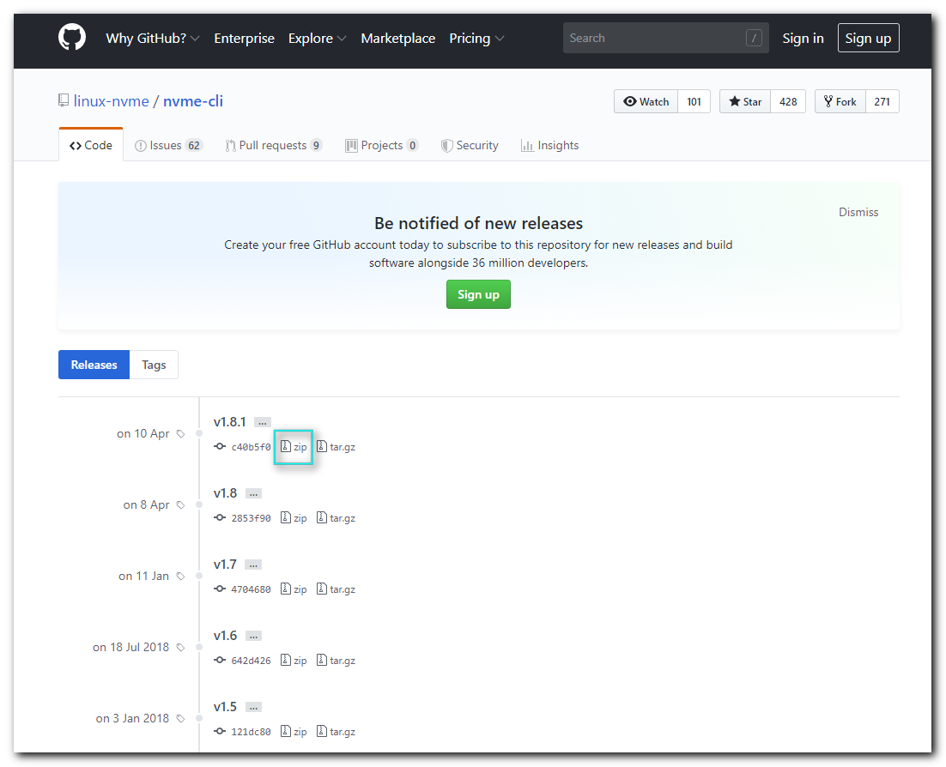

[s.belogrud@TCS4357]# scp /drives/c/Users/s.belogrud/Downloads/nvme-cli-1.8.1.zip bsv@m1-timelinedb01p:/tmp/
nvme-cli-1.8.1.zip 100% 1038KB 1.0MB/s 00:00
[s.belogrud@TCS4357]#

[root@m1-timelinedb01p nvme-cli-1.8.1]# cat /etc/redhat-release
CentOS release 6.8 (Final)

[root@m1-timelinedb01p 20190712-1613]# cp /tmp/nvme-cli-1.8.1.zip .
[root@m1-timelinedb01p 20190712-1613]# unzip nvme-cli-1.8.1.zip

[root@m1-timelinedb01p 20190712-1613]# cd nvme-cli-1.8.1/

[root@m1-timelinedb01p nvme-cli-1.8.1]# make && make install
NVME_VERSION = 1.8.1
cc -D_GNU_SOURCE -D__CHECK_ENDIAN__ -O2 -g -Wall -Werror -std=gnu99 -I. -DNVME_VERSION='"1.8.1"' -o argconfig.o -c argconfig.c
cc -D_GNU_SOURCE -D__CHECK_ENDIAN__ -O2 -g -Wall -Werror -std=gnu99 -I. -DNVME_VERSION='"1.8.1"' -o suffix.o -c suffix.c
cc -D_GNU_SOURCE -D__CHECK_ENDIAN__ -O2 -g -Wall -Werror -std=gnu99 -I. -DNVME_VERSION='"1.8.1"' -o parser.o -c parser.c
cc -D_GNU_SOURCE -D__CHECK_ENDIAN__ -O2 -g -Wall -Werror -std=gnu99 -I. -DNVME_VERSION='"1.8.1"' -o nvme-print.o -c nvme-print.c
cc -D_GNU_SOURCE -D__CHECK_ENDIAN__ -O2 -g -Wall -Werror -std=gnu99 -I. -DNVME_VERSION='"1.8.1"' -o nvme-ioctl.o -c nvme-ioctl.c
cc -D_GNU_SOURCE -D__CHECK_ENDIAN__ -O2 -g -Wall -Werror -std=gnu99 -I. -DNVME_VERSION='"1.8.1"' -o nvme-lightnvm.o -c nvme-lightnvm.c
cc -D_GNU_SOURCE -D__CHECK_ENDIAN__ -O2 -g -Wall -Werror -std=gnu99 -I. -DNVME_VERSION='"1.8.1"' -o fabrics.o -c fabrics.c
cc -D_GNU_SOURCE -D__CHECK_ENDIAN__ -O2 -g -Wall -Werror -std=gnu99 -I. -DNVME_VERSION='"1.8.1"' -o json.o -c json.c
cc -D_GNU_SOURCE -D__CHECK_ENDIAN__ -O2 -g -Wall -Werror -std=gnu99 -I. -DNVME_VERSION='"1.8.1"' -o nvme-models.o -c nvme-models.c
cc -D_GNU_SOURCE -D__CHECK_ENDIAN__ -O2 -g -Wall -Werror -std=gnu99 -I. -DNVME_VERSION='"1.8.1"' -o plugin.o -c plugin.c
cc -D_GNU_SOURCE -D__CHECK_ENDIAN__ -O2 -g -Wall -Werror -std=gnu99 -I. -DNVME_VERSION='"1.8.1"' -o plugins/intel/intel-nvme.o -c plugins/intel/intel-nvme.c
cc -D_GNU_SOURCE -D__CHECK_ENDIAN__ -O2 -g -Wall -Werror -std=gnu99 -I. -DNVME_VERSION='"1.8.1"' -o plugins/lnvm/lnvm-nvme.o -c plugins/lnvm/lnvm-nvme.c
cc -D_GNU_SOURCE -D__CHECK_ENDIAN__ -O2 -g -Wall -Werror -std=gnu99 -I. -DNVME_VERSION='"1.8.1"' -o plugins/memblaze/memblaze-nvme.o -c plugins/memblaze/memblaze-nvme.c
cc -D_GNU_SOURCE -D__CHECK_ENDIAN__ -O2 -g -Wall -Werror -std=gnu99 -I. -DNVME_VERSION='"1.8.1"' -o plugins/wdc/wdc-nvme.o -c plugins/wdc/wdc-nvme.c
cc -D_GNU_SOURCE -D__CHECK_ENDIAN__ -O2 -g -Wall -Werror -std=gnu99 -I. -DNVME_VERSION='"1.8.1"' -o plugins/wdc/wdc-utils.o -c plugins/wdc/wdc-utils.c
cc -D_GNU_SOURCE -D__CHECK_ENDIAN__ -O2 -g -Wall -Werror -std=gnu99 -I. -DNVME_VERSION='"1.8.1"' -o plugins/huawei/huawei-nvme.o -c plugins/huawei/huawei-nvme.c
cc -D_GNU_SOURCE -D__CHECK_ENDIAN__ -O2 -g -Wall -Werror -std=gnu99 -I. -DNVME_VERSION='"1.8.1"' -o plugins/netapp/netapp-nvme.o -c plugins/netapp/netapp-nvme.c
cc -D_GNU_SOURCE -D__CHECK_ENDIAN__ -O2 -g -Wall -Werror -std=gnu99 -I. -DNVME_VERSION='"1.8.1"' -o plugins/toshiba/toshiba-nvme.o -c plugins/toshiba/toshiba-nvme.c
cc -D_GNU_SOURCE -D__CHECK_ENDIAN__ -O2 -g -Wall -Werror -std=gnu99 -I. -DNVME_VERSION='"1.8.1"' -o plugins/micron/micron-nvme.o -c plugins/micron/micron-nvme.c
cc -D_GNU_SOURCE -D__CHECK_ENDIAN__ -O2 -g -Wall -Werror -std=gnu99 -I. -DNVME_VERSION='"1.8.1"' -o plugins/seagate/seagate-nvme.o -c plugins/seagate/seagate-nvme.c
cc -D_GNU_SOURCE -D__CHECK_ENDIAN__ -O2 -g -Wall -Werror -std=gnu99 -I. -DNVME_VERSION='"1.8.1"' nvme.c -o nvme argconfig.o suffix.o parser.o nvme-print.o nvme-ioctl.o nvme-lightnvm.o fabrics.o jso
n.o nvme-models.o plugin.o plugins/intel/intel-nvme.o plugins/lnvm/lnvm-nvme.o plugins/memblaze/memblaze-nvme.o plugins/wdc/wdc-nvme.o plugins/wdc/wdc-utils.o plugins/huawei/huawei-nvme.o plugins/n
etapp/netapp-nvme.o plugins/toshiba/toshiba-nvme.o plugins/micron/micron-nvme.o plugins/seagate/seagate-nvme.o
install -d /usr/local/sbin
install -m 755 nvme /usr/local/sbin
make -C Documentation install-no-build
make[1]: Entering directory `/root/work/20190712-1613/nvme-cli-1.8.1/Documentation'
install -d -m 755 /usr/local/share/man/man1
install -m 644 nvme-admin-passthru.1 nvme-ana-log.1 nvme-attach-ns.1 nvme-changed-ns-list-log.1 nvme-compare.1 nvme-connect-all.1 nvme-connect.1 nvme-create-ns.1 nvme-delete-ns.1 nvme-detach-ns.1 n
vme-device-self-test.1 nvme-dir-receive.1 nvme-dir-send.1 nvme-disconnect-all.1 nvme-disconnect.1 nvme-discover.1 nvme-dsm.1 nvme-effects-log.1 nvme-endurance-log.1 nvme-error-log.1 nvme-flush.1 nv
me-format.1 nvme-fw-commit.1 nvme-fw-download.1 nvme-fw-log.1 nvme-gen-hostnqn.1 nvme-get-feature.1 nvme-get-log.1 nvme-get-ns-id.1 nvme-get-property.1 nvme-help.1 nvme-huawei-id-ctrl.1 nvme-huawei
-list.1 nvme-id-ctrl.1 nvme-id-ns.1 nvme-id-nvmset.1 nvme-intel-id-ctrl.1 nvme-intel-internal-log.1 nvme-intel-lat-stats.1 nvme-intel-market-name.1 nvme-intel-smart-log-add.1 nvme-intel-temp-stats.
1 nvme-io-passthru.1 nvme-list-ctrl.1 nvme-list-ns.1 nvme-list-subsys.1 nvme-list.1 nvme-lnvm-create.1 nvme-lnvm-diag-bbtbl.1 nvme-lnvm-diag-set-bbtbl.1 nvme-lnvm-factory.1 nvme-lnvm-id-ns.1 nvme-l
nvm-info.1 nvme-lnvm-init.1 nvme-lnvm-list.1 nvme-lnvm-remove.1 nvme-netapp-ontapdevices.1 nvme-netapp-smdevices.1 nvme-ns-descs.1 nvme-ns-rescan.1 nvme-read.1 nvme-reset.1 nvme-resv-acquire.1 nvme
-resv-register.1 nvme-resv-release.1 nvme-resv-report.1 nvme-sanitize-log.1 nvme-sanitize.1 nvme-security-recv.1 nvme-security-send.1 nvme-self-test-log.1 nvme-set-feature.1 nvme-set-property.1 nvm
e-show-regs.1 nvme-smart-log.1 nvme-subsystem-reset.1 nvme-telemetry-log.1 nvme-toshiba-clear-pcie-correctable-errors.1 nvme-toshiba-vs-internal-log.1 nvme-toshiba-vs-smart-add-log.1 nvme-wdc-cap-d
iag.1 nvme-wdc-clear-assert-dump.1 nvme-wdc-clear-pcie-correctable-errors.1 nvme-wdc-drive-essentials.1 nvme-wdc-drive-log.1 nvme-wdc-drive-resize.1 nvme-wdc-get-crash-dump.1 nvme-wdc-get-drive-sta
tus.1 nvme-wdc-get-pfail-dump.1 nvme-wdc-id-ctrl.1 nvme-wdc-purge-monitor.1 nvme-wdc-purge.1 nvme-wdc-vs-internal-log.1 nvme-wdc-vs-nand-stats.1 nvme-wdc-vs-smart-add-log.1 nvme-write.1 nvme-write-
uncor.1 nvme-write-zeroes.1 nvme.1 /usr/local/share/man/man1
make[1]: Leaving directory `/root/work/20190712-1613/nvme-cli-1.8.1/Documentation'
install -d /usr/local/share/bash-completion/completions
install -m 644 -T ./completions/bash-nvme-completion.sh /usr/local/share/bash-completion/completions/nvme
install -d /usr/local/share/zsh/site-functions
install -m 644 -T ./completions/_nvme /usr/local/share/zsh/site-functions/_nvme
[root@m1-timelinedb01p nvme-cli-1.8.1]#

[root@m1-timelinedb01p nvme-cli-1.8.1]# nvme --list
Node SN Model Namespace Usage Format FW Rev
---------------- -------------------- ---------------------------------------- --------- -------------------------- ---------------- --------
/dev/nvme0n1 BTLF743000L04P0DGN INTEL SSDPEDKX040T7 1 4.00 TB / 4.00 TB 512 B + 0 B QDV10130
[root@m1-timelinedb01p nvme-cli-1.8.1]# nvme smart-log /dev/nvme0n1
Smart Log for NVME device:nvme0n1 namespace-id:ffffffff
critical_warning : 0
temperature : 20 C
available_spare : 99%
available_spare_threshold : 10%
percentage_used : 0%
data_units_read : 49,029,673
data_units_written : 84,793,087
host_read_commands : 739,645,191
host_write_commands : 10,599,135,906
controller_busy_time : 675
power_cycles : 2
power_on_hours : 7,293
unsafe_shutdowns : 0
media_errors : 3,096
num_err_log_entries : 3,095
Warning Temperature Time : 0
Critical Composite Temperature Time : 0
Thermal Management T1 Trans Count : 0
Thermal Management T2 Trans Count : 0
Thermal Management T1 Total Time : 0
Thermal Management T2 Total Time : 0
[root@m1-timelinedb01p nvme-cli-1.8.1]#
You have mail in /var/spool/mail/root
[root@m1-timelinedb01p nvme-cli-1.8.1]#

